Apache Airflow Hands-On Exercise

Exercise: Daily Student Task Workflow

- By Sureshkrishna B

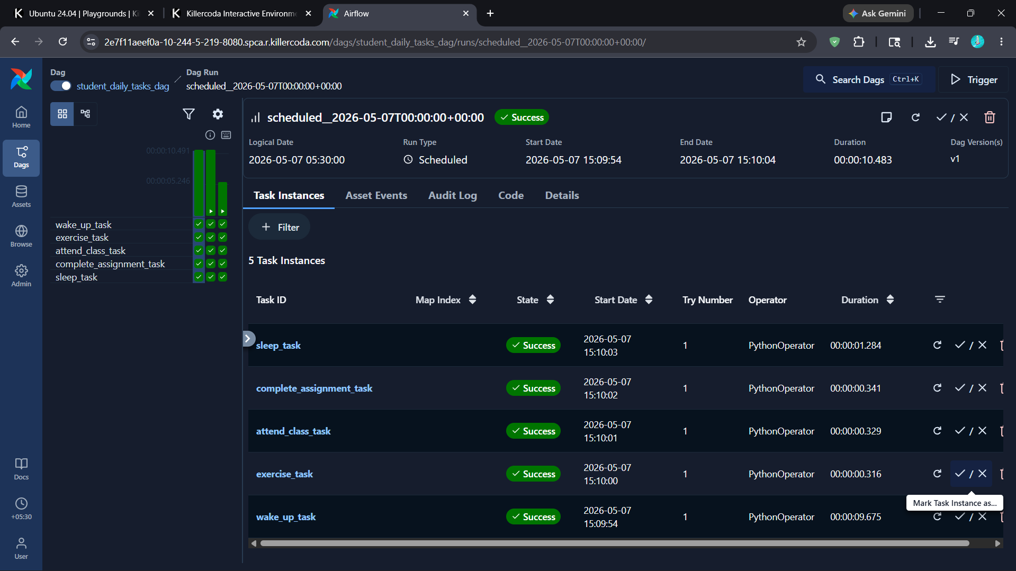

from airflow import DAG
from airflow.operators.python import PythonOperator
from datetime import datetime
def wake_up():
print("Student woke up at 6 AM")
def exercise():
print("Student completed morning exercise")
def attend_class():
print("Student attended Python class")
def complete_assignment():
print("Student completed Airflow assignment")
def sleep():
print("Student went to sleep at 10 PM")
with DAG(
dag_id='student_daily_tasks_dag',
start_date=datetime(2025, 1, 1),
schedule='@daily',
catchup=False
) as dag:
wake_up_task = PythonOperator(
task_id='wake_up_task',
python_callable=wake_up
)
exercise_task = PythonOperator(
task_id='exercise_task',
python_callable=exercise
)
attend_class_task = PythonOperator(
task_id='attend_class_task',
python_callable=attend_class
)
complete_assignment_task = PythonOperator(
task_id='complete_assignment_task',
python_callable=complete_assignment
)
sleep_task = PythonOperator(
task_id='sleep_task',
python_callable=sleep
)
wake_up_task >> exercise_task >> attend_class_task >> complete_assignment_task >> sleep_task

